Scenix
Virtual Peripheral Guidelines
Rev 0.998

Chris Fogelklou
and the
Applications Team
Scenix, Inc.
February 24, 2000

Index of Proposed Guidelines

Page #. - Subject.
6 - Structure of an Application with Virtual Peripheral Modules
7 - RAM
8 - Labels
8 - Standardized Directives
8 - Standard !Option Setup
9 - Standard Mode Register Setup
10 - SX28/SX52BD Compatibility
11 - Lookup Tables (Jump Tables)
13 - Memory Location Dependencies
14 - Page Boundaries
15 - Subroutines in the Second Page of Program Memory
16 - Defining Addresses
17 - Saving CPU Bandwidth
17 - Making Frequency Scaleable
18 - Making Virtual Peripheral Modules Look and Act as Modules
18 - Labeling Sections
19 - Main Program
19 - Port Access
20 - Port Direction
20 - Define the ISR in Locations $0 to $1ff
20 - Worst-Case Cycle Count Must Not Exceed RTCC Interval
21 - Selecting the Interrupt Rate and Oscillator Frequency
22 - Use the Multi-Threaded ISR Template
Index of Proposed Guidelines

INTRODUCTION

This document describes the formats, conventions, and coding guidelines by which we can make integrating various Virtual Peripheral modules into a design as "cut and paste" as possible for a Scenix application developer. By applying a familiar model consistently across all Virtual Peripheral modules, we can keep the Scenix design methodology simple and attractive to new users.

A Virtual Peripheral is a software peripheral that interacts with the Application Software in the same way as a hardware peripheral. Implementing peripherals in software speeds development time and decreases a product's time to market.

The concept of Virtual Peripheral has been around for many years, but the hardware to make the concept practical did not exist until Scenix released the Scenix SX communications controller in 1997. The SX device is a cost-effective communications controller, running at up to 100 MIPS. Although speed is an important feature of the SX device, its predictable timing is the essential enabling technology for Virtual Peripheral development. Every instruction in the SX is completely deterministic, in the sense that all instructions execute in a predetermined number of clock cycles (1 cycle for all instructions except branches, which require 3 cycles) and the interrupt latency is fixed (3 cycles for an internal interrupt, 5 cycles for an external interrupt).

All Virtual Peripheral modules run in the "background" of the main application software, as part of an interrupt service routine. The deterministic nature of the SX communications controller gives the interrupt service routine an exact frequency of execution, and all Virtual Peripheral modules, whether a serial bus interface, a timer, or a DTMF generator, can be based on this exact, jitter-free frequency.

Virtual Peripheral modules must run with minimal intervention from the application software, just as though they were hardware peripherals. The application software simply sets or clears flags, loads a few registers, and then lets the Virtual Peripheral do the work. For example, with an A/D Virtual Peripheral, there is no interaction needed from the application software while the conversion is taking place. When the A/D Virtual Peripheral has finished a conversion, it can set a flag to indicate that the application can take the result.

The interrupt service routine is set up to be called at an exact timing interval. For most Virtual Peripheralmodules, the timing can be arbitrary, as long as the sample rate is high enough to accomplish the desired task. Some Virtual Peripheral modules such as UARTs need to run at specific rates, e.g. 1200 baud, 115.2 kbaud, etc. To simplify the interrupt service routine code that performs the UART function, the interrupt service routine is called at a rate that is an exact multiple of the standard UART speeds.

Virtual Peripheral modules for the SX communications controller are usually designed to run from interrupts triggered by the Real-Time Clock/Counter (RTCC). The RETIW instruction performs a return from interrupt that also adjusts the RTCC to control the exact timing of the interrupts. In the Scenix design methodology, the programmer creates a real-time kernel that receives the interrupts and allocates execution time to the various Virtual Peripheral modules that may run.

The main body of the application starts execution at the reset vector, initializes the system, then falls into the main loop. The main loop communicates with the Virtual Peripheral modules through flags. Enable flags signal when a Virtual Peripheral should run, e.g. to request transmitting a character. Status flags indicate when a Virtual Peripheral has completed an operation, e.g. to acknowledge that the character has been transmitted. The main loop does not directly handle interrupts directly, that function being handled entirely in background by the real-time kernel.

Structure of an Application with Virtual Peripheral Modules
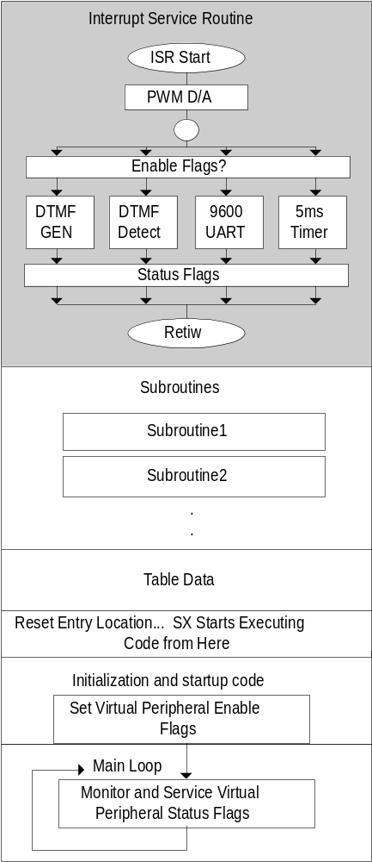
The Interrupt Service Routine calls Virtual Peripheral modules that run transparently to the main program (i.e. in background). The ISR is called at a specific frequency and services all of the Virtual Peripheral modules.

In this illustration, a PWM D/A converter is running as a fixed-rate, high-priority task, and four other tasks (DTMF generation, DTMF detection, UART, and timer) are running at lower priority controlled by enable flags.

The subroutines follow the end of the interrupt service routine.

Table data like strings can be stored after the subroutines.

The entry point for the application (where the program begins running on reset) is before the main loop at the end of the source code.

The main loop of the application is located at the end of the source code. It sets enable flags to start Virtual Peripheral modules running in the Interrupt Service Routine. Virtual Peripheral modules set flags to indicate completion, such as the 5 ms timer expiring.

RAM

Use the following standard label names for global variables in Virtual Peripheral modules and applications released by Scenix:

flags0 equ global_org+0 ; semaphore register reserved
; for flag bits.
isrTemp0 equ global_org+1 ; temporary register reserved
; for use by the interrupt-
; service routine, ISR VP's
localTemp0 equ global_org+2 ; temporary register reserved
; for use by subroutines
localTemp1 equ global_org+3 ; temporary register reserved
; for use by subroutines
localTemp2 equ global_org+4 ; temporary register reserved
; for use by the main program

flags0 stores bitwise operators like flags and function-enabling bits (semaphores).

isrTemp0 is for use ONLY by the interrupt service routine as a global register.

localTemp0 is the temporary register used most often, so routines that are only nested once can destroy this register. It is never guaranteed to maintain its data from routine to routine.

localTemp1 is used by the second nested level, or when a routine needs more than one temporary global register.

localTemp2 follows along the same lines as localTemp1, but is used even less often by more deeply nested routines or as a mainline loop counter, because the other temporary registers will probably be destroyed by the routines called by the mainline.

The documentation for each subroutine will specify which localTemp register it destroys, and which localTemp registers are destroyed by routines nested below this one. If additional temporary registers are needed, they can be called localTemp3 or flags1, etc.

Write Virtual Peripheral modules so they make use of no global RAM locations other than the definitions listed above.

Labels

Keep all labels under two tabs in length.

Use Hungarian notation for all labels. Example:

RS232_receive becomes rs232Receive

Prefix all RAM locations and constants for a specific Virtual Peripheral by a standard, truncated version of that Virtual Peripheral's name. Example:

rxByte ds 1 becomes rs232RxByte ds 1

Left justify all equates and defines, and group all of them into the "Equates and Definitions" area of the source code.

Standardized Directives

Create a set of standard directives for all Virtual Peripheral moduless. A tradeoff is that some Virtual Peripheral modules may become less code-efficient or speed-efficient.

Standard Directives:
- OPTIONX enabled
- STACKX enabled
- CARRYX disabled - if a routine cannot run without CARRYX (like hard-core math), the fact that CARRYX is necessary must be well documented.
- TURBO mode

Standard !Option Setup

- WREG enabled (bit seven of !OPTION = 0), so W is accessible as a file register in location $01, rather than RTCC.
- If possible, a routine that needs to access the RTCC register in location $01 should set !option.7 before executing and, when finished, clear it again to access the WREG in location $01.

Define the default !option set-up as

OPTIONSETUP equ RTCC_PS_OFF|PS_111

Initialization code for WREG in location $01:

mov w,#OPTIONSETUP ; setup option register for RTCC interrupts
mov !option,w ; enabled and no prescaler.
jmp @main

Routines accessing the RTCC register in location $01:

mov !option, #(OPTIONSETUP | RTCC_ON); enable direct access of the RTCC
; by setting !option.7
mov !rb,RTCC ; This code accomplishes absolutely nothing,
jmp :elsewhere ; but it accesses the RTCC register
:elsewhere mov RTCC,rc
mov !option, #OPTIONSETUP ; go back to the option register's default.

After accessing the RTCC register, this routine sets the option register back to its default state. If an exception must be made for speed purposes, it should be well documented that the routine needs the option register set up to allow direct access to the RTCC.

Standard Mode Register Setup

In mainline (interruptible) code,

never assume the value in the mode register, and always update it before using it.
In the Interrupt Service Routine, routines changing the mode register must change it back before exiting. The isrTemp register can be used to store and restore the previous state of the mode register. Example:

mov w,m ; save mode register in isrTemp
mov isrTemp,w
mov w,#$1f ; change mode register
mov m,w
mov !rb,#0 ; change port RB to all outputs
mov w,isrTemp ; restore mode register
mov m,w

SX28/SX52BD Compatibility

Use MACROs or IFDEF/IFNDEF statements to make portions of incompatible code switch in and out for the SX28AC and SX52BD processors.

Example of using an IFDEF statement for SX18/28AC portability to SX52BD and vice-versa:
;------------------------------------------------------------------------------
;VP: 62-byte buffer
; Subroutine: Store W in buffer[pushIndex++]
; INPUTS: data to store in W
; OUTPUTS: data stored in buffer[pushIndex++]
; CHANGES: localTemp1,pushIndex,buffer[pushIndex]
;------------------------------------------------------------------------------
bufferPush
mov localTemp1,w
_bank buffer
mov fsr,pushIndex
mov indf,localTemp1
_bank buffer
inc pushIndex
IFDEF SX28
setb pushIndex.4 ; keep even bank if SX28/18
ENDIF
IFDEF SX18
setb pushIndex.4
ENDIF
retp

Because the RAM in the SX52BD is stored in contiguous banks, and in the SX28 the banks are separated by $20, the IFDEF above will conditionally compile the setb instruction, allowing the pointer to memory to skip the non-existent banks in the SX28AC.

Macros help keep the source code clean. Example of a good macro for incrementing pointers to RAM:

;*************************************************************************
; INCP/DECP macros for incrementing pointers to RAM
;*************************************************************************
INCP macro 1 ; Increments a pointer to RAM
inc \1
IFNDEF SX48_52
setb \1.4 ; If SX18 or SX28, keep bit 4 of the pointer = 1
ENDIF ; to jump from $1f to $30, etc.
endm

DECP macro 1 ; Decrements a pointer to RAM
IFDEF SX48_52
dec \1
ELSE
clrb \1.4 ; If SX18 or SX28, forces rollover to next bank
dec \1 ; if it rolls over. (Skips banks with bit 4 = 0)
setb \1.4 ; Eg: $30 --> $20 --> $1f --> $1f
ENDIF ; AND: $31 --> $21 --> $20 --> $30
endm

SX28/SX52 Compatibility

Example of using a macro (INCP) to make the buffering source code easier to read:

;------------------------------------------------------------------------------
;VP: 62-byte buffer
; Subroutine: Store W in buffer[pushIndex++]
; INPUTS: data to store in W
; OUTPUTS: data stored in buffer[pushIndex++]
; CHANGES: localTemp1,pushIndex,buffer[pushIndex]
;------------------------------------------------------------------------------
bufferPush
mov localTemp1,w
_bank buffer
mov fsr,pushIndex
mov indf,localTemp1
_bank buffer
INCP pushIndex ; Smart-Increment of the pointer to RAM
retp

BANK 0 Locations $10 to $1f
Because the SX48/52BD can only access memory locations $10 to $1f directly, use these locations only as a last resort in programs written for the SX18/28AC, for compatibility with the SX48/52BD.
Extra RAM in the SX48/52BD
Because the SX18/28AC has only half of the RAM of the SX48/52BD, avoid use of the extra RAM in programs written for the SX48/52BD, for compatibility with the SX18/28BD.

Lookup Tables (Jump Tables)

Routines should be clearly documented if they need to be completely within the first half of the page. Lookup tables that may be called by the programmer's own program should have protection against the table extending into the second half of a page. This can be done with the help of macros. By including a tableStart and tableEnd definition in the table, these macros will generate the error message "ERROR: Must be located in the first half of a page." if the table becomes misplaced.

;*********************************************************************************
; Error generating macros
;*********************************************************************************

tableStart macro 0 ; Generates an error message if code that MUST be in
; the first half of a page is moved into the second
; half.
if $ & $100
ERROR 'Must be located in the first half of a page.'
endif
endm

tableEnd macro 0 ; Generates an error message if code that MUST be in
; the first half of a page is moved into the second
; half.
if $ & $100
ERROR 'Must be located in the first half of a page.'
endif
endm

An assembler may implement this function in the future if these standard tableStart and tableEnd definitions are used.

This: Becomes this:

;********************
jmp_table_1
add pc,w
jmp routine_1
jmp routine_2
jmp routine_3
jmp routine_4
;********************

;********************
jmp_table_1
; The code between the
; tableStart and tableEnd
; statements MUST be
; completely within the first
; half of a page. The routines
; it is jumping to must be in
; the same page as this table.
tableStart
add pc,w
jmp routine_1
jmp routine_2
jmp routine_3
jmp routine_4
tableEnd
;********************

Note that the table must be in same page as the call to that table.

Memory Location Dependencies

Routines that are program memory location-dependent must be clearly marked:

;**************************************************************************
; Subroutine - Send string pointed to by address in W register
; Strings MUST be located completely within program memory space from $300
; to $3ff
; INPUTS:
; w - The address of a null-terminated string in program
; memory
; OUTPUTS:
; outputs the string via. RS-232
;**************************************************************************

If possible, defines or equates can be used to simplify this process:

mov m,#3 ; move upper nibble of address of strings into m

becomes

mov m,#STRINGS_ORG>>8; move upper nibble of address of strings into m

Now, as long as the STRINGS_ORG label precedes the strings, this subroutine will work properly, without regard to where the strings are located.

;****************************************************************************************
; String Data
;****************************************************************************************
org STRINGS_ORG ; This label defines where strings are kept in program
; space. All of the following strings must be within the
; same 1/2 page of program memory for send_string to work,
; and they must be preceded by this label.

_hello dw 13,10,'V.23 Transmit (Originate Mode) 2.00',0
_FSK dw 13,10,'Transmitting 75bps FSK >',0

For routines with very location-specific data memory definitions, there should be ample documentation to indicate that the data memory cannot be moved around arbitrarily. Wherever possible, location-specific routines should be avoided.

Page Boundaries

To ensure that several Virtual Peripheral modules, when pasted together, do not cross a page boundary without the programmer’s knowledge, put an ORG statement with one instruction at every page boundary. This will generate an error if adding a subroutine moves another subroutine over a page boundary.
org$0
org$700
org$100
org$200

subroutines/program code…

org $400 ; Even though there's no program,
jmp $ ; put code here to generate an error
; if the code before it crosses a
; page boundary.
org $500
jmp $
etc…

Subroutines in the Second Page of Program Memory
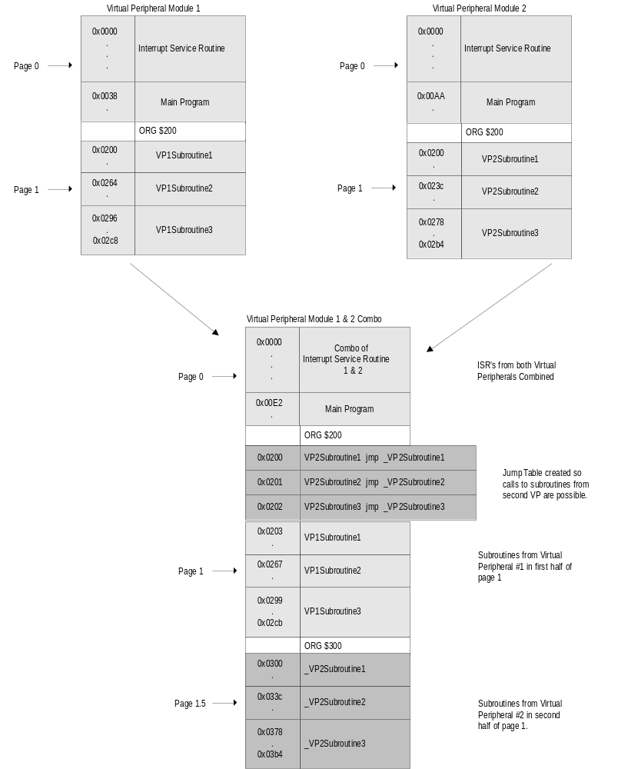If two Virtual Peripheral modules are integrated together, and the subroutines for each Virtual Peripheral are to be placed into the same page, the callable subroutines from one of the Virtual Peripheral modules may need to be moved to the second half of a page. The problem this poses is that labels in the second half of a page can only be jumped to and not called. The solution is to create a jump table for the routines in the second half of the page. Unfortunately, the compromise is that calling a routine through a jump table adds a 3-cycle latency to the subroutine call, and therefore should only be used for routines that are not extremely speed-critical.

There is no simple way to make this job easier for the integrator, so the only solution is to provide ample documentation and examples on creating jump tables.

Defining Addresses

Place a table of ORG statements at the top of the source code with the starting addresses of all Virtual Peripheral modules. Use symbolic names for these addresses, rather than hard-coding them as literal values. This lends itself to separating the Virtual Peripheral modules into separate source files and creating a linker. Indicate whether each segment is moveable or not.

UART_SUBS_ORG equ $300
I2C_SUBS_ORG equ $400
I2C_ISR_ORG equ $600

Now, instead of using the literal values, use the defined values:

org UART_SUBS

For smaller Virtual Peripheral modules, just use PAGE2_ORG, etc.

Example from included code:

;****************************************************************************************
; Program memory ORG defines
;***************************************************************************************
INTERRUPT_ORG equ $0 ; Interrupt must always start at location zero
INTERRUPT_ORG2 equ $100 ; Some more of the ISR is stored in location $100
RESET_ENTRY_ORG equ $1FB ; The program will jump here on reset.
SUBROUTINES_ORG equ $200 ; The subroutines are in this location
STRINGS_ORG equ $300 ; The strings are in location $300
PAGE3_ORG equ $400 ; Page 3 is empty
MAIN_PROGRAM_ORG equ $600 ; The main program is in the last page of program
; memory.

And:

;****************************************************************************************
org INTERRUPT_ORG ; First location in program memory.
;------------------------------------------------------------------------------
; Interrupt Service Routine
;------------------------------------------------------------------------------
; Note: The interrupt code must always originate at address $0.
;
; Interrupt Frequency = (Cycle Frequency / -(retiw value)) For example:
; With a retiw value of -163 and an oscillator frequency of 50MHz, this
; code runs every 3.26us.
;------------------------------------------------------------------------------

Saving CPU Bandwidth

Instead of running the Virtual Peripheral on every interrupt, try to write it so it can run on every fourth or eighth interrupt. This makes integrating many Virtual Peripheral modules much less likely to overflow the number of cycles available for each interrupt, because the Interrupt Service Routine need only run one thread at a time.

Making Frequency Scaleable

Whenever possible, Virtual Peripheral modules should be written so that they are scaleable to work with virtually any interrupt rate. Virtual Peripheral modules that are written in this way include the A/D and D/A converters, the timers, FSK and DTMF generation and detection, LCD interface, and many others. Only the resolution or timing constants change as the interrupt rate changes.

Some Virtual Peripheral modules, however, require very specific interrupt rates. An example of this is the UART, which must be run at a 2^{n} multiple of the desired UART rate. In this case, it must be made very clear to the programmer how to calculate the interrupt rates for all Virtual Peripheral modules, so that a frequency-dependent Virtual Peripheral like the UART can be chosen as the rate-determining factor, and all other Virtual Peripheral modules can have their constants re-calculated for the chosen rate.

; 19200 baud
; baud_bit = 4 ;for 19200 baud
; start_delay = 16+8+1 ; " " "
; int_period = 163 ; " " "

This type of definition gives the programmer no idea what to do if he wants to change the interrupt rate, while the following definition makes the change much more obvious:

; Execution rate/16
; baud_bit = 4 ; For a baud rate of FS/16
; start_delay = 16+8+1 ; " " "
; Execution rate/8
; baud_bit = 3 ; For a baud rate of FS/8
; start_delay = 8+4+1 ; " " "
; Execution rate/4
; baud_bit = 2 ; For a baud rate of FS/4
; start_delay = 4+2+1 ; " " "

This clears up what the definitions do to the UART speeds, and that the UART speed is tightly tied in to the interrupt rate. If the programmer wants a slower UART, or a slower interrupt rate, or both, the change is more intuitive.

If possible, let the compiler calculate the constant for the programmer, as in this example:

Fs = 9600 ; sampling frequency for DTMF detection
Bits = 65536 ; 2^16 is the value of the phase accumulator

f697_l equ ((Bits * 697)/Fs) & $0ff
f697_h equ ((Bits * 697)/Fs) >> 8

In this example, the constant used to generate a 697 Hz signal is generated at compile time, as Fs changes. If the programmer wants to speed the execution rate of the frequency-generating Virtual Peripheral, he or she can simply change its execution rate in the ISR and scale the FS constant accordingly.

As long as the execution rates of each of the Virtual Peripheral modules are multiples of one another, they can all use the same retiw value.

Unfortunately, the downfall of having only one jitter-free interrupt is that running Virtual Peripheral modules at rates that don't have a common denominator such as 115 kHz and 250 kHz is not possible.

Making Virtual Peripheral Modules Look and Act as Modules

- Keep each module short. The entire routine, beginning to end, should fit in the editor's window without scrolling.
- Indicate whether each ISR routine is variable-length or fixed-length in its header.
- Indicate the worst-case cycle time for each ISR routine in its header.
- Use only Scenix mnemonics as defined in the datasheet in final, releasable source code.

- Provide only one way in and out of each routine.
- Callable ISR routines: have a bank instruction for the routine performed before the call.

- Maximum ISR call-nesting: two levels, leaving nestable levels for the mainline program.

- As a rule, always return with a retp instruction rather than a ret instruction (retp returns from subroutine across page boundaries).

Labeling All Sections: RAM, Constants, ISR, Subroutines

- Each section of the Virtual Peripheral must be clearly labeled to show which Virtual Peripheral it belongs to. This includes RAM allocations, program constants, Virtual Peripheral (ISR) routines, and callable subroutines.

- The labels should be machine readable, to enable a smart software tool in the future that can automatically cut and paste Virtual Peripheral modules.

- Start the Virtual Peripheral module with:

- ;VP_begin <moduleVP>
And end it with:
;VP_end ; End cut/paste <moduleVP>

;VP_begin RS232Receive

RS232RxBank = $

RS232RxCount ds 1 ;number of bits received
RS232RxDivide ds 1 ;receive timing counter
RS232RxByte ds 1 ;buffer for incoming byte

;VP_end ; End cut/paste for RS232Receive

Main Program

Place the main routine at the end of the source code to make it easy to find. This means that if the first page is used for anything other than main program source code, a reset_entry must be placed in the first page, along with a page instruction and a jump instruction to the beginning of the main program.

Example:

;****************************************************************************************
org RESET_ENTRY_ORG
;****************************************************************************************
;------------------------------------------------------------------------------
reset_entry ; Program starts here on power-up
page _reset_entry
jmp _reset_entry
;------------------------------------------------------------------------------

Then… at the start of the main routine on another page:

;****************************************************************************************
org MAIN_PROGRAM_ORG
;****************************************************************************************
;****************************************************************************************
; RESET VECTOR
;****************************************************************************************
;*********************************************************************************
; Program execution begins here on power-up or after a reset
;*********************************************************************************
_reset_entry
; program start up source code here

Port Access

To ease integrating multiple Virtual Peripheral modules that all need access to the same ports,
- Use pin definitions rather than port definitions.
- All port accesses should be made through symbolic names. Example:
setb rb.6 becomes setb LEDPin

Port Direction

When a Virtual Peripheral must dynamically change a port direction register, it should do this through the use of a port direction buffer. The port direction register stores the initialized state of the port direction register, and any changes made to the port direction register are made to the buffer first, and then the buffer is written to the port direction register.
If two Virtual Peripheral modules are combined, and both need to dynamically modify the same port direction register, they instead operate on the buffer for that port's direction register. The buffer is then written to the port direction register. Use banked RAM and standardized names for port direction register buffers:
portBufBank equ $
RADirBuf ds 1
RBDirBuf ds 1
RCDirBuf ds 1
RDDirBuf ds 1
REDirBuf ds 1
These rules apply to other special mode-register addressable registers, such as the pull-up enable registers, etc.

Define the ISR in Locations $0 to $1ff.

Keeps the ISR structure compact and easy to read. Use extra pages only if necessary.

Worst-Case Cycle Count Must Not Exceed RTCC Interval

Exceeding the interrupt timing will cause the processor to miss an interrupt, which throws off the timing of every interrupt-driven Virtual Peripheral in the application.

Selecting the Interrupt Rate and Oscillator Frequency

Getting the desired interrupt rate from the desired oscillator frequency may be one of the most confusing parts of designing an interrupt-driven Virtual Peripheral. This procedure may be used to select these parameters.

1. Choose a desired interrupt frequency (irqFreq) based on the Virtual Peripheral modules you want to run.

- Example: Choose 230.4 kHz for 4 times oversampling on a 57.6 kbps UART

2. Choose an oscillator frequency (oscFreq.) Higher sample-rate Virtual Peripheral modules will require higher oscillator frequencies. If power is not an issue for your design, a 50-MHz oscillator frequency is a safe bet for almost all Virtual Peripheral modules.

- Example: Choose 50 MHz

3. Divide your oscillator frequency by your interrupt frequency. This is your ideal RETIW value.

- Calculate RETIW value = (oscFreq/irqFreq)

- Calculate 50 MHz/230.4 kHz = 217.01

4. Round your RETIW value to the nearest integer value between 0 and 255.

- Round RETIW value to an integer

- Round to 217

- If the number exceeds 255, then slow down the RTCC by enabling its prescaler (reducing its time between RTCC increments by an integral power of 2 between 2 and 256), or choose a lower oscillator frequency. If the number is 90 or less, there may not be enough time to service each interrupt, so increase the oscillator frequency or decrease the interrupt frequency.

5. Calculate your actual interrupt frequency to see if it is close enough to your desired interrupt frequency by dividing the oscillator frequency by the RETIW value.

- Actual Frequency = (oscFreq/RETIWVal * prescaler)

- Check Actual Frequency = 50,000,000 Hz/217 = 230.415 kHz ≅ 230.4 kHz

- If the difference between the desired interrupt frequency and the actual interrupt frequency is too much, try recalculating with different oscillator frequencies.

Use the Multi-Threaded ISR Template.

This method produces a far smaller worst-case cycle time count, and enables a larger number of Virtual Peripheral modules to run simultaneously. It also produces "empty" slots that future Virtual Peripheral modules can occupy.

1.
Start with the multi-threaded ISR template shown on the next page.

2.
Determine how often your tasks need to run. For example, a 9600-baud UART can run well at a sampling rate of only 38400 Hz, so don't run it faster than this.

3. Place your modules into the threads of the ISR. If a module needs to be run more often, call it at double the rate or whatever rate meets its requirements.

4. Split complicated Virtual Peripheral modules into several modules, keeping the high-speed portions of the Virtual Peripheral modules as small and quick as possible, and run the more complicated, slower processing part of the Virtual Peripheral at a lower rate.

For example, in the Caller-ID detection program, the zero-cross-timer component of the Virtual Peripheral runs at double the speed of all of the other components, because it needs high resolution timing of the transitions on a pin. The other components of the Caller-ID Virtual Peripheral run at a slower rate, yet take a longer time to run when they are run. It is not necessary for them to run any faster, however, and doing so would increase the amount of CPU bandwidth used by the FSK detection Virtual Peripheral with no added benefit. (See the block diagram of the Caller-ID detection Interrupt Service Routine on the following pages.)

Because the ISR can now be viewed as a structure, made up of modules, it is easier for the user to increase and decrease the sampling rate by moving the modules around in the source code. Because only a few tasks are called in each interrupt, the flow of each interrupt is smaller and more easily understood. It is much simpler than an interrupt structure made up of many modules running consecutively, each jumping to the next.

Index of following pages:

Page 23: Block diagram of a complex application, simplified through the use of a multi-threaded ISR (14 simultaneous Virtual Peripheral modules)
Page 24: Block diagram of an actual application following this document's guidelines. (FSK generation with 10 simultaneous Virtual Peripheral modules)
Page 25: Block diagram of the ISR for the Caller-ID detection application.

